WiD documentation

# Introduction

Wid is a note taking app whose name stands for “Write it Down”. Wid seemed to roll of the tongue more smoothly. This app will work with any device on mobile or desktop and have numerous features as a part of my journey to learn as much about full-stack software development as I can

# Requirements and Detailed Features

**Requirements:** Responsive Web Design, able to scale to any size screen. Appealing color palette and UI/UX design choices. Numerous features listed below.

**Features (in order of importance):**

* **Text Editor:** 
  + Change Font (?)
  + Undo
  + Font-Size
  + Font-Color
  + Bold
  + Italic
  + Underline
  + Strike-Through
  + Highlight (?)
  + Bullet / Number / Checklist (?)
  + Inserting links
  + Importing Images
  + Embedding YouTube Videos, Google Maps, other services
* **Saving notes (Browser vs Login?)**
  + Keep Track of Date / Time.
  + Account System
    - Google / GitHub Sign in API
    - Database
    - Hashing / Password Management
* **Keyword Search**
* **Sharing notes (as a link)**
* **Sign in / Out**
  + View Profile
  + Profile Stores information
  + Delete Account
  + Google Sign in (maybe)
  + Confirmation Email (Maybe)

# Design

**Front-End:**

* The first step, which I’ve recently discovered that I enjoy, is to draw up a pre-design on a whiteboard or whiteboard app. This will give me a general idea of the app structure to keep the app maintainable from the start. Styling will most likely not be integrated (at least fully) until after most of the logic, but I like having a framework for my projects before blindly going at them. **Pre-Design can be found below:**

**User Profile Page Mock-up:**

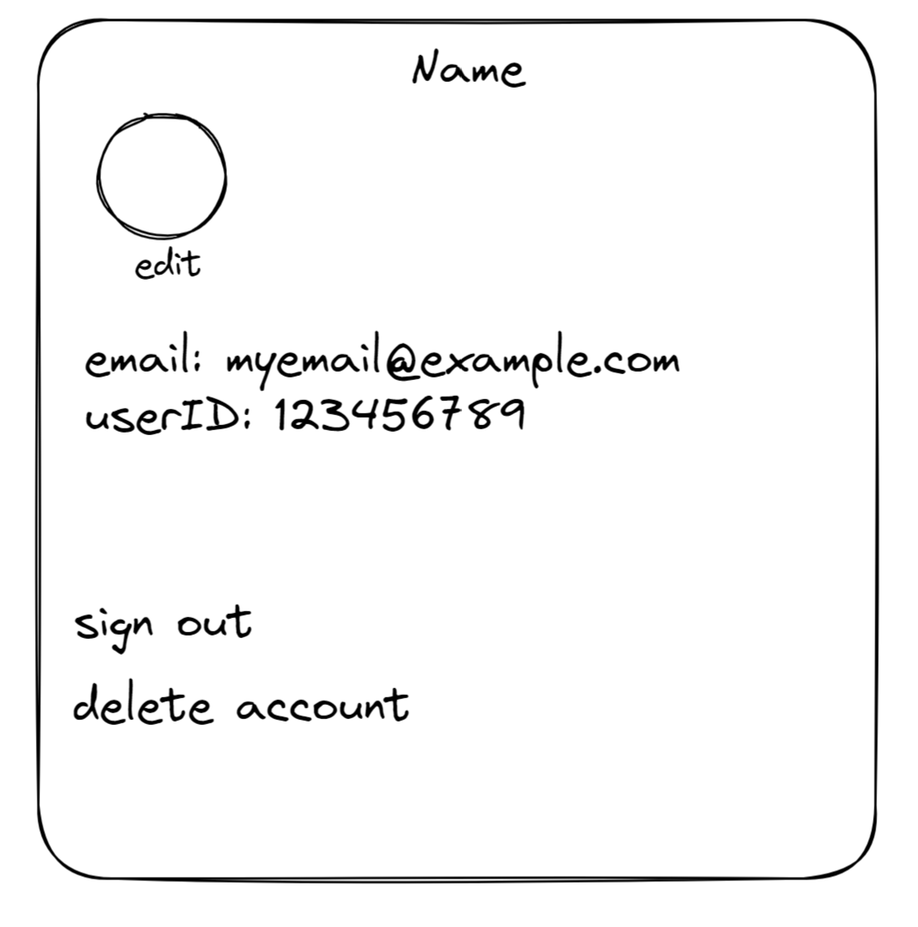

**Back-End:**

# Testing and Analysis

# Deployment

**Authentication: Firebase**

**Database: Firebase**

**Hosting Service:Netlify**

# Lessons Learned / Challenges